Colloidal Silver

Generator

(DC-51)

Instructions

REQUIRED DISCLAIMER:

IMPORTANT NOTICE: Please understand that we cannot be responsible for any effects, good or bad, due to the use of the colloidal silver generator. No claims are made as to specific benefits resulting from the use of colloidal silver. Statements relating to any health benefits from colloidal silver have not been evaluated by the FDA and are not intended to diagnose, treat, cure, or prevent any disease. Information conveyed is based on records and research for your information only and is not meant to imply that you will experience similar beneficial results. We are NOT licensed medical practitioners and are prohibited by law from diagnosing or prescribing anything. No statement contained herein should be taken as medical advice.

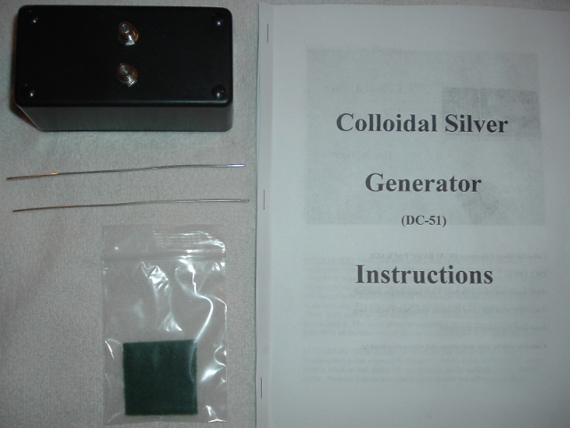

Colloidal Silver Generator DC-51 BASIC PACKAGE

INCLUDES:

-Fully tested generator with three 9 volt batteries pre-installed.

-Two .9999 ultra fine silver electrode wires each 6 inches long.

-Scrub pad for cleaning electrodes.

-Complete step by step instructions and information booklet.

Before You Begin……..

WATER: In order to make the purest colloidal silver possible, you will need Distilled or de-mineralized Water. Distilled/de-mineralized water has had all the unnecessary minerals and impurities removed so all you have left is pure water. You can purchase distilled or de-mineralized water at most supermarkets or make it yourself if you know how.

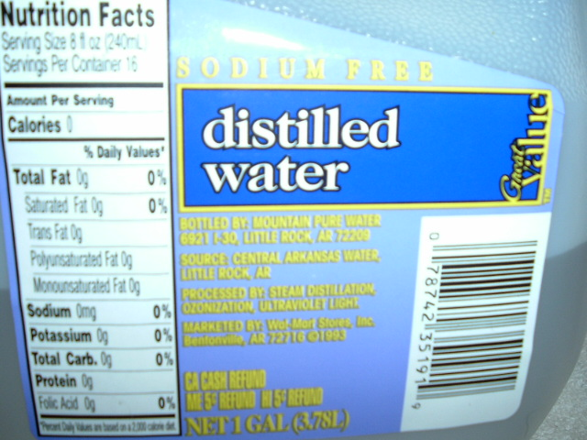

CONTAINER: Next, you will need a cup or some sort of container to make your colloidal silver in. This container can be made of glass, ceramic or plastic, but NOT metal and needs to be at least 6 inches high (if possible) to accommodate the silver wires. Choose a container that will hold a little more liquid than the amount of colloidal silver that you want to make. For example, if you wish to make 14 ounces of colloidal silver, your container should hold 15 or 16 ounces. (Such as a standard ice tea glass). The main thing to remember here is that you want at least 80% of the silver electrodes to be submerged in the distilled water.

LOCATION: Silver is light sensitive, so you will need to choose a location that is not exposed to DIRECT, NATURAL SUNLIGHT, away from a window and definitely not outside, while making your colloidal silver. Normal indoor household light should not affect your silver.

NOW you’re ready to make colloidal silver!

How to make PURE Colloidal Silver

1. Clean and polish your silver electrode wires. Take the scrub pad provided in your kit and lightly buff or clean both electrodes. You will need to do this before and after making each batch of colloidal silver. This keeps any impurities or foreign matter such as dust, off of the electrodes. But also after making silver, you will see that they really need to be cleaned.

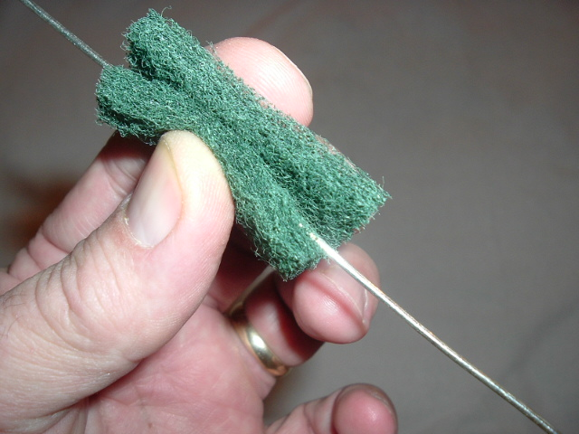

2. Insert your clean .9999 silver electrodes into the holes on the top of your generator, one wire in each hole. Pure silver wire is soft, so you might need to straighten them out a bit by hand. And don’t worry you will not be shocked by the electrical charge.

Something to remember here also is that although your generator is on all the time, it will not generate any electrical current or use any battery power UNLESS both of the silver wires are immersed in water, OR they are touching each other.

3. Measure out the amount of distilled water you desire to make into silver, such as 8, 16, or 32 ounces (a quart Mason jar works great for this one, as seen in my photos).

Do not fill your container to the very top. Leave at least a 1/2 inch space from the top of the water to the rim of the container, but not more than 2 inches. The water should be at least room temperature, but warmer water works best. If the water is too cold, warm it in a microwave or on a stovetop in a clean stainless steel pot. Warmer water makes silver faster.

4. Turn the generator upside down and place it over the top of your container (glass or jar) with the wires in the water. Make sure the wires are evenly spaced apart all the way down the length of the wires.

If your jar is too short (or wires too long) and the wires touch the bottom of the container, you can bend them back opposite of each other (see picture below) so they won’t touch the bottom of your container. The main thing to remember is to NOT let the wires touch each other, or the process will not work.

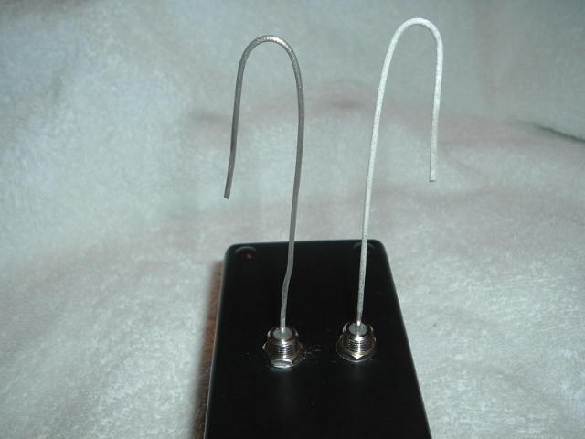

5. Set a timer for 30, 45, 60 or 90 minutes, depending on how much water you are using and how strong you want to make your silver. After about 15 minutes (more or less), you will notice small hydrogen bubbles coming off one of the electrodes, and a gray-brown cloud which looks like smoke coming off the other electrode. This cloud is the microscopic silver particles (ions) coming off the electrode. You will also notice a fuzzy black growth (see pictures below) starting to form on the other electrode. This fuzzy black growth is normal and is the negatively charged silver particles building up on the electrode. The positively charged particles (ions) are the ones that stay suspended in the water.

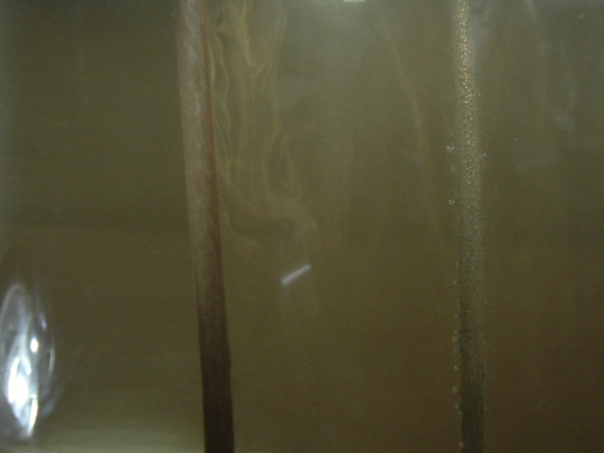

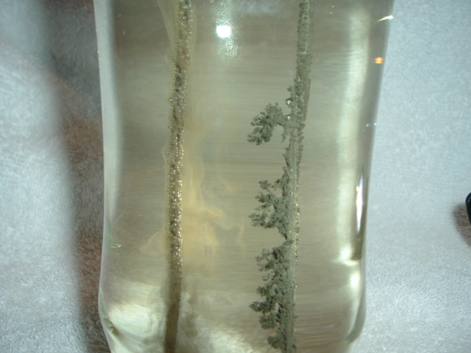

6. After 30 minutes (or 45, 60 or 90), lift the generator off the container (glass or jar) and set it aside. Both the wires should be quite a bit darker now. This indicates that the process is working or has worked. If the wires are still clean, and you have not seen the electrodes produce what is mentioned above, then check the batteries. A quick way to do this is to bend the electrodes until they lightly touch each other at the tips. If you see a little tiny spark, then the batteries are good.

If you get an excessive buildup of the black fuzzy build-up on the one electrode during the process, it is perfectly ok to remove the generator at times and simply wipe off the excess with a paper towel. Some of the build up may float around the water during the process, and drop off the electrode. This is harmless, just simply strain your colloidal silver into another container through a paper coffee filter (see picture below). But these black particles are quite harmless.

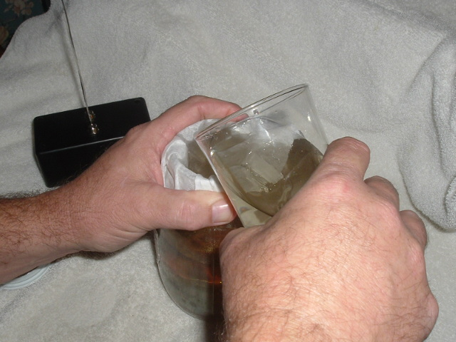

7. Depending on how much water you used and how long you left the generator in the water, your silver will range from 2 to 14 PPM (parts per million). On the next page is a general guideline chart to help. By the end of the process, both electrodes will be black (or dark). This is silver oxide. Clean the electrodes with the scrub pad provided (you may also use a plain fine steel wool). You’re ready to start another batch, or put the electrodes away until their next use.

If you desire a stronger solution you can repeat the process with the same water at 15 minute increments until the desired strength (PPM) is reached. Generally about 10 PPM is sufficient for most all needs.

YIELD OF COLLOIDAL SILVER

Volume of Water

Process Time 4 OZ 8 OZ 16 0Z 32 OZ

15 Minutes 4-8 PPM 0-1 PPM

30 Minutes NR 2-4 PPM 0-1 PPM

45 Minutes NR 6-8 PPM 2-4 PPM 0-1 PPM

60 Minutes NR 11-14 PPM 6-8 PPM 2-4 PPM

75 Minutes NR NR 11-14 PPM 6-8 PPM

90 Minutes NR NR NR 11-14 PPM

NR= Not Recommended

The chart above lists the approximate yields you can expect to get when making your colloidal silver using 6 inch electrodes, with at least 80% of the electrodes submerged in water. These yields are only approximations. Actual yields will depend on a number of variables such as: exact water volume, purity of water, water conductivity, water temperature, surface area of the electrodes (how much silver is immersed in water), amount of current (fresh batteries will be stronger than used ones), and total processing time.
PPM stands for Parts Per Million and refers to the number of silver particles in each million parts of water. When engaging the electrolytic method of making colloidal silver, the silver particles (also called ions) always break off of the electrodes at the SAME particle size, 1.26 angstroms, or approximately .001 microns.

Your colloidal silver should turn a nice light amber color in a couple of hours or overnight, and should resemble the picture below.

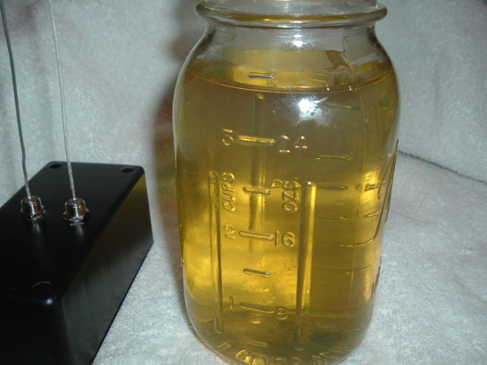

STORAGE OF COLLOIDAL SILVER

Silver is light sensitive. Keep it in a cool, dark place but do not refrigerate. We recommend storing your colloidal silver in a dark or tinted glass bottle or jar. Do not store your colloidal silver in a plastic bottle unless it is made of a non-reactive plastic such as a hydrogen peroxide bottle. Plastic can build up an electrical charge and cause your silver particles to fall out of suspension. If using an old hydrogen peroxide bottle, be sure to rinse it out thoroughly before filling it with colloidal silver. Do not store your colloidal silver near speaker cabinets or other strong magnetic fields. Full potency can be retained for at least a month when your silver is properly stored.

REPLACING YOUR SILVER ELECTRODES

Your silver electrode wires will wear out eventually. Each time you make colloidal silver, tiny silver particles break off of the one electrode. (A good reason to switch the electrodes around between batches so they don’t stay in the same hole). Eventually after enough particles break off, the electrodes will fall apart. The electrodes should last about one year, depending on how often you use them and how much colloidal silver you make. When you need to replace your electrodes, simply contact the company or person who sold you this CS Generator.

WHAT IS THE BEST CONCENTRATION TO USE?

In today’s market, colloidal silver is sold in many different concentrations (ppm’s) ranging from 5 PPM to 500 PPM. Faced with the choice of making your own colloidal silver, you’re probably wondering what concentration is best to use? There is no real answer to that question. Everyone seems to have their own opinion on what concentration is better.

Keep in mind that no disease causing organism can live in the presence of even MINUTE traces of the chemical element of metallic silver. This would suggest that a solution of as little as 5 PPM would be just as beneficial as a solution of 20 PPM. The body’s ability to process the tiny atoms of colloidal silver make silver build up in the body impossible. The Environmental Protection Agency’s Poison Control Center reports a “NO TOXICITY” listing for colloidal silver. In fact, it appears that harmlessness is one of the attributes of the colloidal state regardless of content.

A solution of 10 PPM seems to be the most common concentration used. There is no compelling evidence that a solution of more than 10 PPM is more beneficial. Although recent research is showing that there is no reason to use a solution of more than 5 PPM. The choice is yours. Just remember that you cannot overdose on colloidal silver.

REPLACING THE BATTERIES

Your colloidal silver generator is powered by three 9 volt batteries which should last you six months to a year, depending on usage (such as once a week). To change the batteries, remove the 4 screws on the back of the generator, remove the cover, then unsnap the batteries from the clips on the top of the batteries. Replace with new heavy duty or alkaline batteries.

HOW DOES COLLOIDAL SILVER WORK?

The silver particles in colloidal silver contain a positive charge and are attracted to virus, fungi, bacterium and other single celled pathogens (disease causing organisms). When the silver particles attach themselves to these pathogens (through the positive charge) they disable the pathogen’s oxygen metabolism enzyme. In simple terms, they suffocate and kill the bad guys. Once the bad guy is dead, the silver particle releases its bond and searches for a new pathogen to attach to. The dead pathogens are then cleared out of the body by the immune, lymphatic and elimination systems. Unlike pharmaceutical antibiotics which destroy beneficial enzymes (the good guys), colloidal silver leaves these tissue cell enzymes intact. This makes colloidal silver absolutely safe for humans, reptiles, plants and all multi-celled living matter.

Taken orally, colloidal silver is absorbed from the mouth into the bloodstream, then travels quickly to the body cells. For faster absorption, swish colloidal silver under your tongue for a few seconds before swallowing. In 3 or 4 days the silver will have accumulated in the tissues enough for benefits to begin. After ingesting colloidal silver, it circulates in the body for about a week to two weeks before being eliminated by the kidneys, lymph system and bowel. A regular daily intake of colloidal silver is recommended to protect the body against dangerous pathogens.

In cases of minor burns, an accumulation of colloidal silver can hasten healing, reducing scar tissue and infection. Colloidal silver is painless on cuts, abrasions, in open wounds, can be sprayed into the nostrils for a stuffy nose, and even used in a baby’s eyes, because, unlike antiseptics, it does not destroy tissue cells. It is impossible for single celled organisms to mutate into silver resistant forms, as happens with conventional antibiotics. Therefore, no tolerance to colloidal silver ever develops. Colloidal silver will not interact or interfere with other medications. Inside the body, silver forms no toxic compounds, nor reacts with anything other than a germ’s oxygen metabolizing enzyme. Colloidal silver is a safe, natural remedy for all that plagues mankind.

Colloidal silver does not interact with any other medications or upset the stomach. In fact, it is a digestive aid. It does not sting the eyes. Medical journal reports and documented studies spanning the past hundred years indicate no known side effects whatsoever, from oral or intravenous administration of colloidal silver in animal or human testing. It has been used with good results under the most demanding health care circumstances.

Some Suggested Uses

Based on a colloidal silver solution of 5-10 PPM

Maintenance – All Ages: As a dietary supplement, take 1-4 tablespoons per day.

Moderate to Severe Infections: (Common cold symptoms induced by bacteria or flu virus, all bacterial, viral, fungi, yeast, and parasitic infections): Take the following dose every 2-3 hours until condition improves, then continue with maintenance dosage.

Infants- 0-1 Year: ¼ tsp to ¼ tbsp
Children-1-12 Years: ½ tsp to ½ tbsp
Adults-12 Years and over: 1 tsp to 1 tbsp

Sore Throat: Gargle 1 teaspoon to 1 tablespoon, then swallow. Repeat once every hour until condition improves.

Earache: Apply several drops in affected ear, use with small cotton ball if desired. Re-apply every 2 hours until condition improves.

Animal Care: Put 1 tsp to 1 tbsp of colloidal silver in pet’s water bowl each time you fill it. For severe infections (parvo, distemper, etc.) use an eyedropper and give 1 tsp to 1 tbsp, 3 times a day directly in pets mouth until condition improves. Continue putting colloidal silver in water bowl.

Use on open wounds, cuts, scrapes, burns etc. May be applied to skin rashes or skin conditions such as psoriasis.

*************************************************************

Some people prefer to use a TDS (total dissolved solids) PPM meter, to check or verify their final PPM solution. These meters are especially useful to check your DISTILLED WATER before you begin the process of making colloidal silver. The PPM of your distilled water should be 0 (zero) Parts Per Million right out of the jug BEFORE you begin the process. Some companies today selling “distilled” water actually add chemicals or minerals back into the water after distilling it. This is NOT what you want to use. It will quickly produce a brown milky dirty looking solution which is unusable. So it’s a GOOD IDEA to check your Distilled Water BEFORE beginning the process of making colloidal silver. You can order a good PPM meter from me at a very reasonable price. Just visit our website below.

To order more silver electrodes or another CS Generator, go to:

WWW.ECONOMYSILVERGENERATOR.COM

Or email me at: danielcohran@hotmail.com

Daniel Cohran
CS Solutions
P.O. Box 332
Chickamauga, GA 30707

